CSC1034 Group Project: Individual Summary Report – Ryan Alex 40450422

Key Development Contributions:
- I mainly contributed with JavaScript functionality, along with multiple HTML pages, slight adjustments to the pages with CSS, and a good bit of SQL queries embedded within web components.
- When we came up with the idea, I took it upon myself to create a mind map, to structure the story, and give the team a base framework, and a target to work towards.
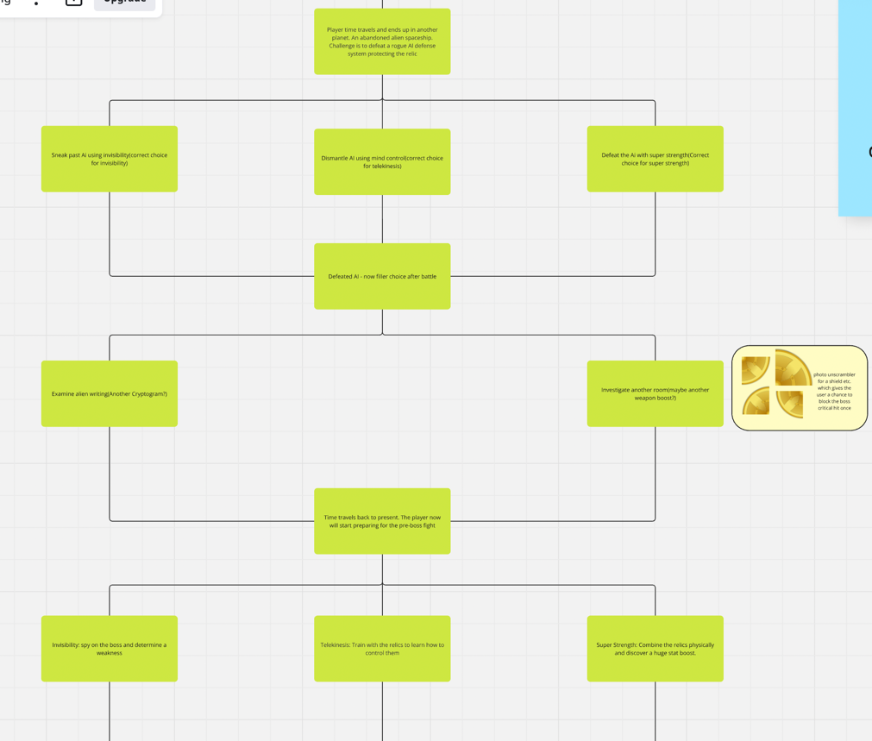
- HTML & CSS: I developed multiple pages in the game with HTML and CSS, I developed the first boss fight, the eternal battle ending and the discard item page.

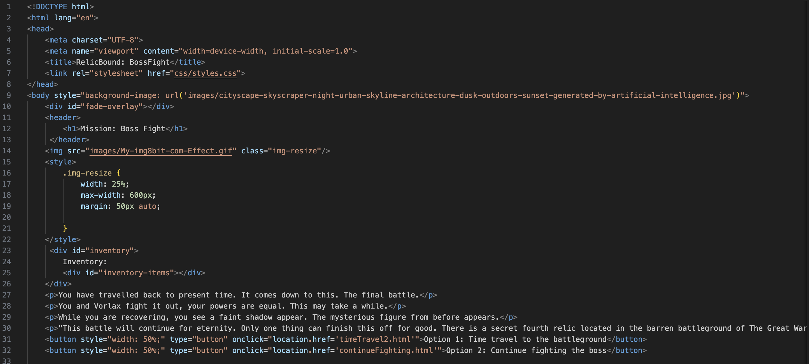

- JavaScript & mySQL: This is where I mainly focused on. In the project specification, the game needed to have an inventory aspect, where the user had an inventory that saved the items collected throughout the game. The items had to be saved in the database. I had to make sure that the correct items where saved using the itemID, and make sure that they were saved to the right person, using userInvId. To do this, I had to make multiple functions inspired by the dbTester.html file provided to us. I used it to execute certain mySQL queries that needed to be carried out.

The most difficult part for me while doing this code, was to ensure that the items were being saved to the right person(userInvId), that meant that I had to get the userId, then fetch the userInvId, and use that value along with the itemID to run the mySQL query.
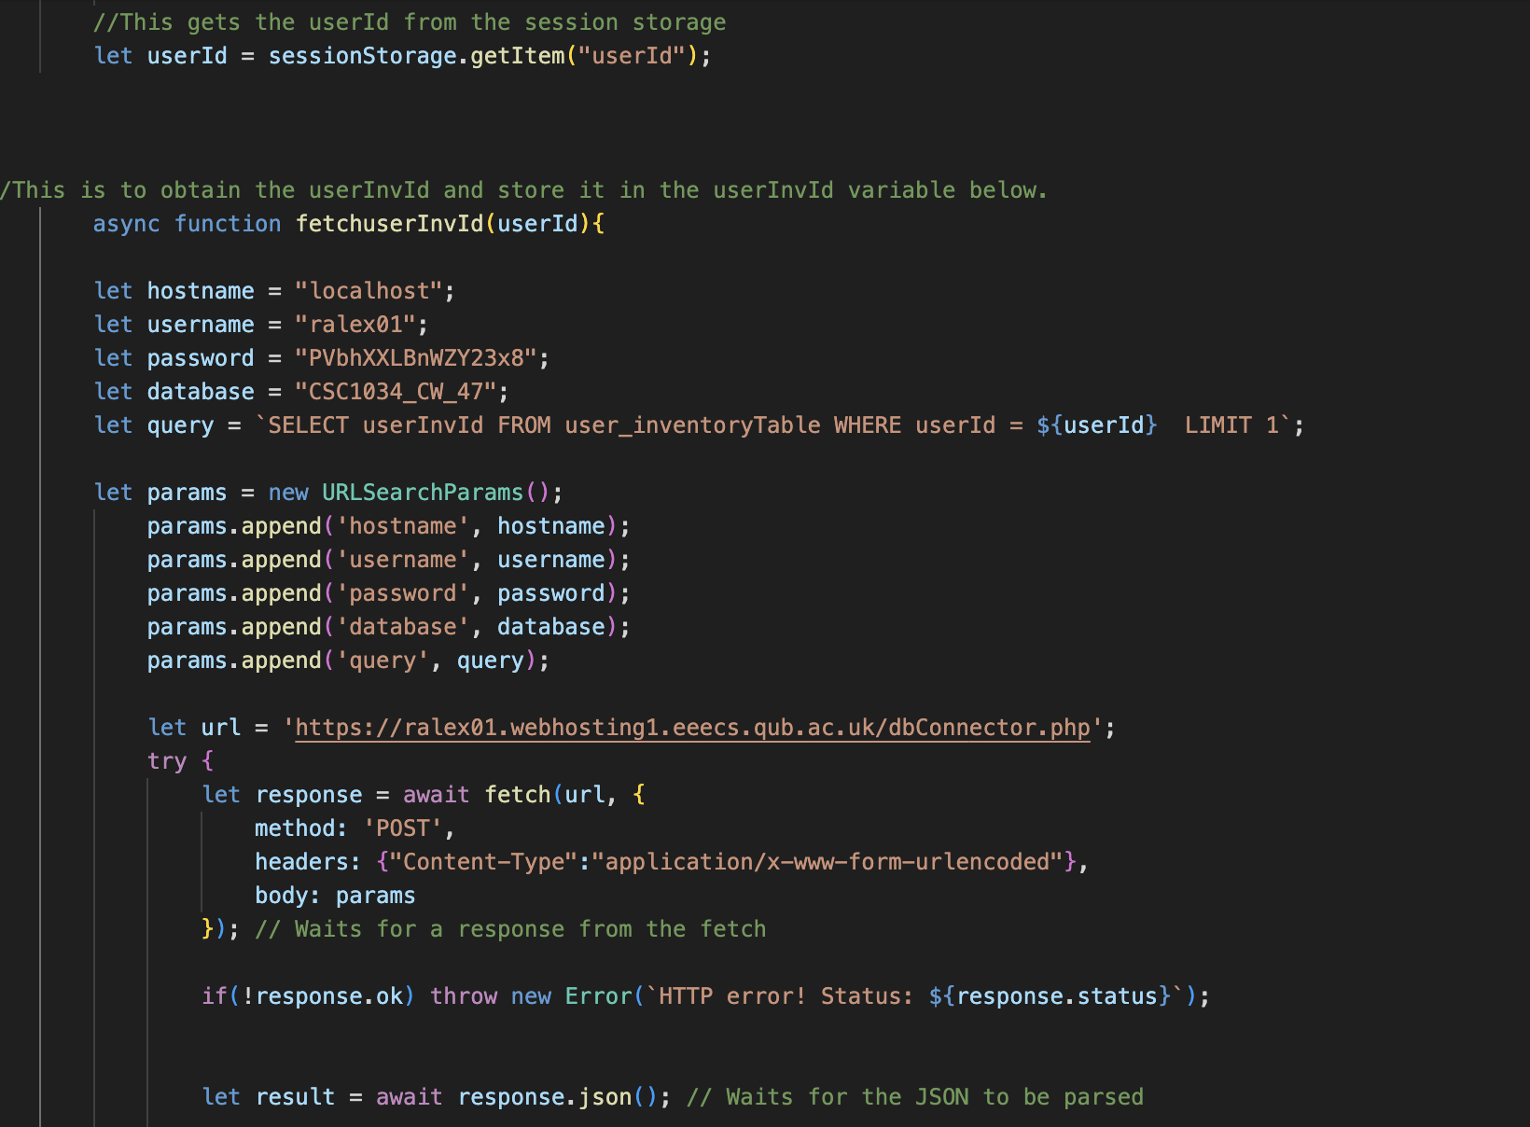
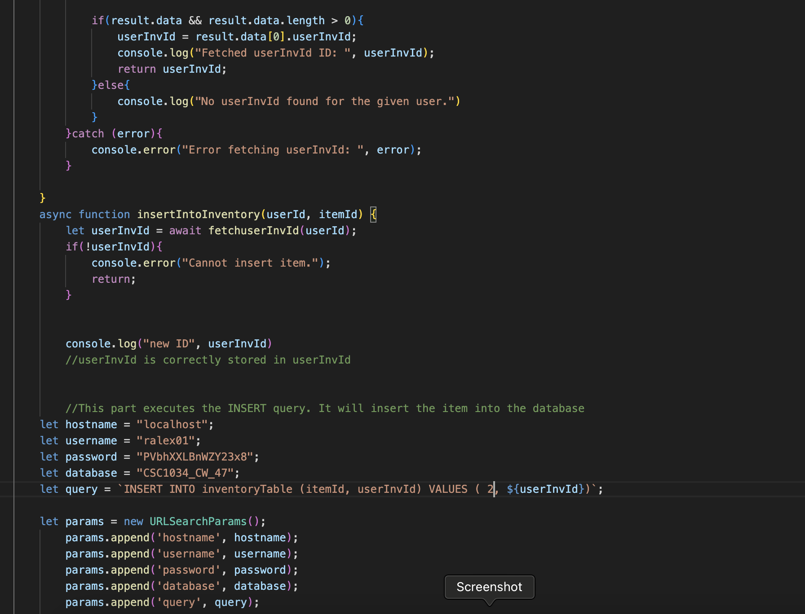

After that, I had to create the functionality for the discard item page. I had to do the same procedure, but a different mySQL query. I made sure to delete the itemID given, from the specific person that is playing. For UI, I made another function that removed the item image from the inventory depending on the choice made by the user. For example, if they chose to discard The Sword of Souls, the image of the sword would be deleted.
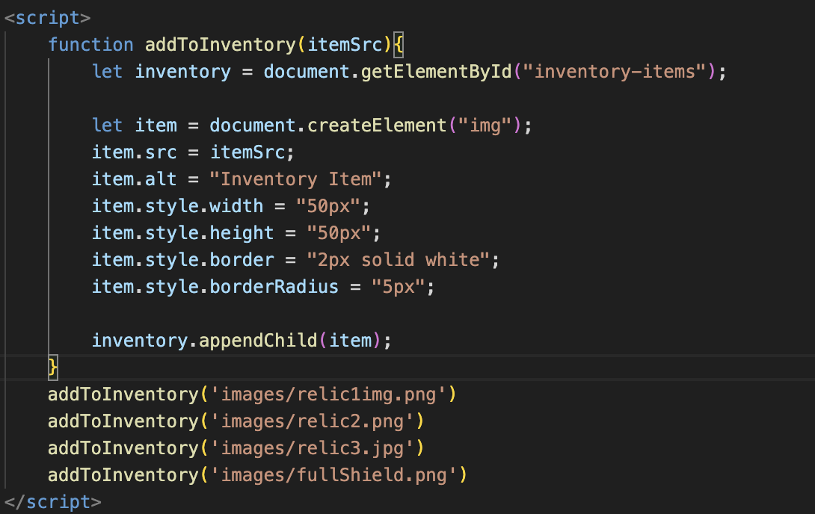

Finally, I also created the UI for the inventory. I had to make a JavaScript function shown above, I made sure I added the appropriate images to the inventory bar, at the right time.

I also helped develop the fetch functions for power validation for relic 3, which made sure that the player’s choice correctly corresponds to the choice made, and directs them to the correct page. It fetches the power, and ensures that the player is directed to the success page if they choose the correct option, and the fail page if they don’t.

The most advanced features of the game that I did, was the inventory functionality, and the power validation. due to its technical complexity and difficulty for me personally. I had to go over lectures and notes multiple times to fully grasp an understanding of the functionality of the fetch function. I used the dbTester.html file provided as a template, while making changes with error handling, and other tweaks in the functionality depending on the query. Examples of the inventory code are shown above.

AI was used to aid me in my journey of coding and developing my part of this project. It was used for debugging, and finding issues with my code, that I couldn’t figure out. It especially helped me with debugging errors with my fetch functions for the inventory.

